Time series analysis :

preconditions that data should pass to have the better time series analysis
https://www.youtube.com/watch?v=xJCV0aPqcaA&index=38&list=PLJlKGwy-7Ac68Oqy6h1qWJkrx7X5a0Awk

- Spurious regression

Subsetting: http://www.ats.ucla.edu/stat/r/modules/subsetting.htm
General links for dates : http://www.statmethods.net/input/dates.html

1.Read csv
csvData <- read.csv("C:/santosh info/Azure/sample data/atd_Online_new.csv", header = TRUE , sep=",")

2.Get column names :
> names(csvData)
[1] "Project.ID" "Status" "Severity" "Project" "Detected.on.Date"
[6] "Issue.Type" "Priority" "Closing.Date" "No.of.days"

3.Get smaller subset
smalldata <- csvData[, c(1,5,8)]

1 ,5 ,8 are columns

4.C function : makes a vector
x <-c(1:3)
> x
[1] 1 2 3

> x +4
[1] 5 6 7
-------------------------
y <- c("fsdf", "fsdf")
> y
[1] "fsdf" "fsdf"

5.Convert date into default format
Ex: date
21/01/2015 Get it into : 2015-01-21
smalldata$Detected.on.Date <- as.Date(smalldata$Detected.on.Date, "%d/%m/%Y")

- Variables present in workspace
ls()
7. Get the length of each element of a list or atomic vector (is.atomic) as an integer or numeric vector.
Usage
lengths(x, use.names = TRUE)

Word clod formation r script :

https://studio.azureml.net/Home/ViewWorkspaceCached/a4bb36383cd54023915ff3c164675ec0#Workspaces/Experiments/Experiment/a4bb36383cd54023915ff3c164675ec0.f-id.7f284630f6414aa7b0fb4f6c6d6c23b5/ViewExperiment
# Map 1-based optional input ports to variables
frame <- maml.mapInputPort(1) # class: data.frame

library(tm)

library(wordcloud)
library(RColorBrewer)

myCorpus = Corpus(VectorSource(frame[[2]]))

stopword_list <- c()

myCorpus = tm_map(myCorpus, tolower)
myCorpus = tm_map(myCorpus, removePunctuation)
myCorpus = tm_map(myCorpus, removeNumbers)
myCorpus = tm_map(myCorpus, removeWords, stopwords("english"))
myCorpus <- tm_map(myCorpus, removeWords, stopword_list)
myCorpus <- tm_map(myCorpus, stemDocument)
myCorpus <- tm_map(myCorpus, PlainTextDocument)

myDTM = TermDocumentMatrix(myCorpus, control = list(minWordLength = 1))

m = as.matrix(myDTM)

v = sort(rowSums(m), decreasing = TRUE)

myNames <- names(v)
d <- data.frame(word=myNames, freq=v)
pal2 <- brewer.pal(8,"Dark2")
wordcloud(d$word, d$freq, min.freq=3, max.words=100, colors = pal2)

# Select data.frame to be sent to the output Dataset port
maml.mapOutputPort("d");

Apply functions on data frame like toLower , Upper etc

library(dplyr)
df <- mutate_each(df, funs(toupper))

library(dplyr)
library(tm)
Category <- data.frame(Category)
Category <- mutate_each(Category, funs(tolower))

8 . Merge 2 columns
Remove characters from each row of a column

Spliiting sentences

s_mer <-NULL
s_mer <- as.data.frame(s_mer)
for(i in 1:lengths(x[2])){
s2 <- data.frame(x[i,2],x[i,1], tokenize_sentences(as.character(x[i,2])))

if(i == 1){
s_mer <- s2
} else{
#s_mer <- merge(x = s_mer, y = s2 , all = TRUE)
s_mer <- rbind(s_mer,setNames(s2,names(s_mer)))

}
}

Export or write data into csv file
write.table(s_mer, "filename2.csv", row.names=FALSE, sep=",")

Connect to database from R
Link : https://www.r-bloggers.com/accessing-mysql-through-r/

install.packages("RMySQL")
library(RMySQL)
mydb = dbConnect(MySQL(), user='root', password='Ctl@1234', dbname='verita_jboss', host='localhost')
rs = dbSendQuery(mydb, " SELECT distinct project FROM demo.defectsummary;")
data = fetch(rs, n=-1)

Add dummy column :
x$rowid<- as.numeric(x$rowid)

x$rowid<- as.numeric(x$rowid)

String [] text =
Rowid[] =
Scoer [] =
Add values in column :
Or create a sample dataset

> x<- cbind(rbind("sadas","sun","rere"), rbind(100,10,1000))
> x
[,1] [,2]
[1,] "sadas" "100"
[2,] "sun" "10"
[3,] "rere" "1000"

Name columns

colnames(x)<- c("word","size")
word size
[1,] "sadas" "100"
[2,] "sun" "10"
[3,] "rere" "1000"

Sorting in r by a column :

y <- x[order(x$size,decreasing = TRUE),]

word size
3 rere 1000
1 sadas 100
2 sun 10

Select top rows from dataframe

z <- head(y,2)
word size
3 rere 1000
1 sadas 100

Add rows
http://vitalflux.com/learn-r-append-rows-data-frame/

Reporting in r

Generate pdf and other formats

http://rprogramming.net/create-html-or-pdf-files-with-r-knitr-miktex-and-pandoc/

Using Knitr package

SEq_along

> a <- c("aa", "bb", "cc", "dd", "ee")
> a
[1] "aa" "bb" "cc" "dd" "ee"
> seq_along(a)
[1] 1 2 3 4 5

> seq_along(c("2","3"))
[1] 1 2

Seq()
Seq(4)
[1]1, 2,3 ,4

Ggplot2

Data , asthetics , geometrics , ...other optional fileds

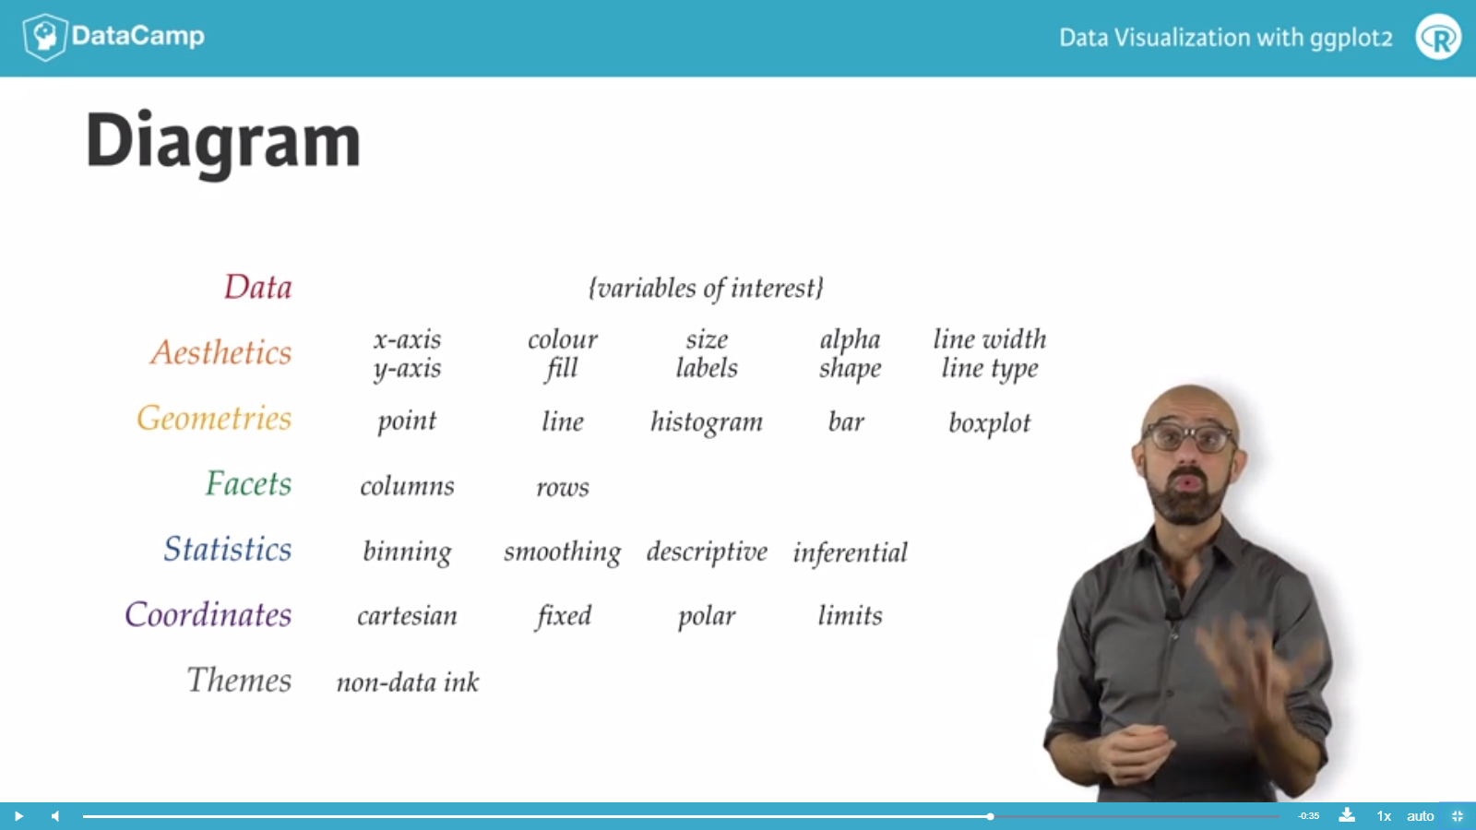

List mehods or funtions in a package

ls(package:tidytext)
ls(package:tm)
Etc

